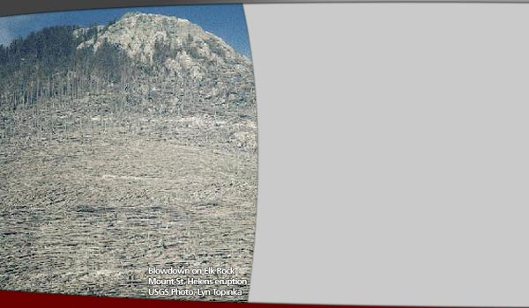

**Blow-Downs**

When pyroclastic materials (gas and tephra) are forced out of a volcano in an explosive eruption, the blast can be extremely forceful. Volcanic blasts can be directed vertically (straight up), laterally (sideways along the ground), or at some angle between. Lateral blasts are most devastating because all of the energy of the blast is directed across land.

There are three zones associated with a lateral blast. The direct blast zone is the area that experiences the maximum force of the blast. Usually everything in this zone is completely obliterated - either burned or carried away. The channelized blast zone is an intermediate zone, where the blast still carries enough force and energy to level anything in its path, even whole forests. The last zone, the seared zone is a fringe area where trees and structures are left standing, but still affected by the heat and gas content of the blast.

The direction of the blast can be illustrated by the position of the felled trees and other debris. The action of a volcanic blast knocking down trees and buildings is called a "blow-down."

**Climate Change**

Climatologists have been studying the interactions between volcanoes and Earth's global climate. It is thought volcanic particles in the air are responsible for some degree of global cooling. The extent of the cooling depends on the force of the eruption, the height of the ash column, the volume of ash and gas emitted, and the location of the volcano in relationship to Earth's atmospheric currents.

The effects of some volcanoes can be substantial. For example, the eruption of Indonesia's Tambora volcano in 1815 led to 1816 being called "the year without a summer" as far away as Europe!

The sulfate particles emitted by volcanoes can increase the strength of CFC's (compounds that deplete the ozone layer) in the atmosphere. The effects of volcanic emissions on atmosphere and climate changes are measured and monitored by instruments on satellites. Remote sensing plays a large role in our knowledge of volcanic clouds.

The image shows how the tephra and volcanic gases emitted in the early 1990s by Mount Pinatubo in the Philippines traveled all around the globe. The red and yellow areas show where the volcanic ash was present in the atmosphere. Atmospheric currents carry particulates emitted from the volcano around the globe, affecting weather patterns and temperatures on the other side of the world.

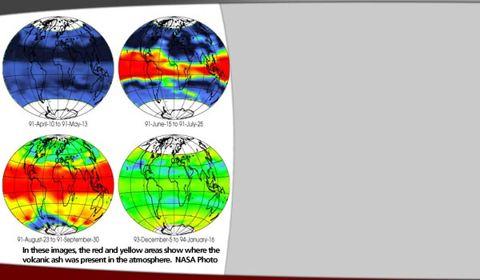

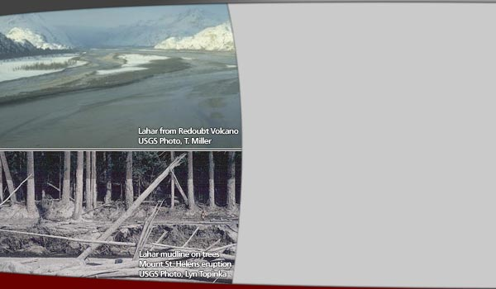

**Lahar**

Lahar is an Indonesian word, used to describe the debris flows and mudflows that originate from a volcano. Lahars contain rock debris and water. Mudflows contain less rock fragments and more water, and flow more cohesively. Debris flows are coarser and have a higher density of rock. They are more viscous and flow much less smoothly.

Because lahars have a high density of rock fragments and originate on a slope, they have high internal strength and can exert enough force to uproot trees, carry boulders and smash buildings as they flow downstream. Lahars can vary greatly in size, from centimeters wide and deep flowing less than 1 meter per second, to hundreds of meters wide and tens of meters deep flowing at tens of meters per second. Large, high-velocity lahars can reach many kilometers from a volcano.

Lahars are triggered by large landslides of water-saturated debris. This saturation is caused by heavy rainfall on volcanic deposits, sudden melting of snow and ice near volcanic vents from radiant heat on the flank of a volcano or from pyroclastic flows, or from water released in the breakout of glaciers and crater lakes.

Lahars can be either hot or cold, depending on the temperatures of the water and debris that they contain. Hot or cool, historically lahars are one of the most devastating volcanic hazards because they pose threats of burial and impact by debris.

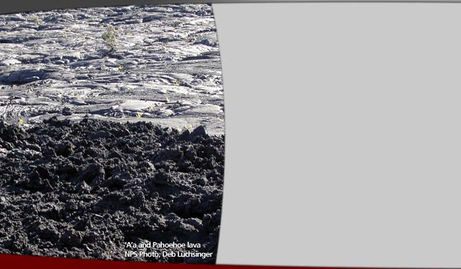

**Lava Flow**

Lava flows can burn, crush, or bury anything in their path. Lava flows are slow enough that they are rarely a threat to human life, and people can evacuate the area where the flow is heading and avoid danger. However, lava can travel at varying speeds. The path and distance of a lava flow can be predicted with knowledge of variables such as rate at which lava is flowing from the vent, fluid properties of the lava (viscosity), volume of lava, slope steepness of the volcano and surrounding landscape, channel geometry, and any obstructions to flow.

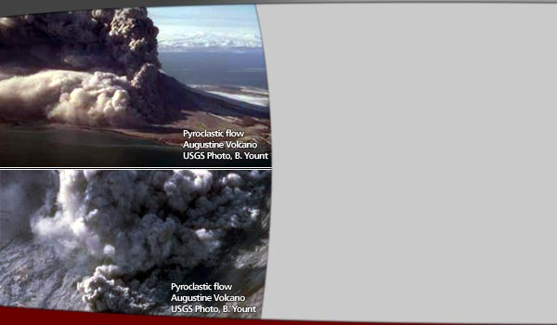

**Pyroclastic Flow**

The word pyroclastic comes from Greek words - pyro meaning "fire" and klastos meaning "broken." Pyroclastics are the materials formed when magma and rock are fragmented during explosive eruptions and ejected from the volcano. Volcanic ash is the smallest pyroclastic fragment. Lapilli, blocks and bombs are larger.

Pyroclastic flows are avalanches of high-temperature rock, ash, and gas that race downslope from a volcano during explosive eruptions. These flows are extremely dangerous because they can reach temperatures of 1500 degrees Fahrenheit and speeds up to 450 miles per hour. At that temperature and speed, they can obliterate anything in their path.

A pyroclastic flow is also called Nuée Ardente, which means "glowing cloud" in French. Depending on the concentration of gases and red-hot incandescent materials, the pyroclastic flow can have a glowing appearance. The flows can originate from the mouth of the volcano, like a pot boiling over. They can also be the result of the fallout from the eruption column.

Pyroclastic surges are low-density versions of the pyroclastic flow. A "hot" pyroclastic surge is made up of dry gas and rock debris with temperatures above 100 degrees Celsius. "Cold" surges contain water and rock debris at temperature below 100 degrees Celsius.

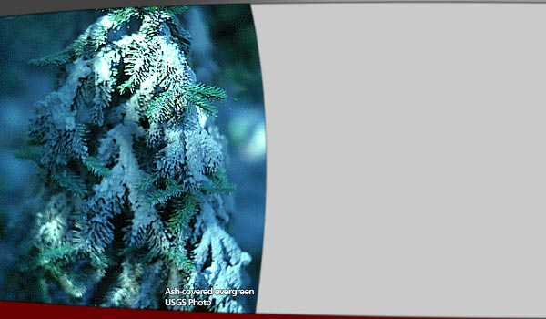

**Tephra/ Ash**

Tephra is the term used to describe solid or molten rock fragments of any size ejected from a volcano. The smallest fragments (less than 2 millimeters in diameter) are called ash. Mid-sized fragments (2 to 64 millimeters in diameter) are called lapilli. Anything ejected from a volcano that is larger than 64 millimeters in diameter is called a block if it was ejected in a solid form and a volcanic bomb if it was ejected in a liquid or semi-solid form.

Tephra clouds can rise thousands of meters into the atmosphere and blanket areas hundreds of kilometers downwind of the eruption with ash. The dense tephra clouds can cause periods of darkness, even at mid-day, affecting plant, animal and human activity. Plants whose leaves are blanketed with ash are unable to perform photosynthesis or respiration. Animals experience disruption in their daily routine due to darkness at unusual times. Animals and humans can experience respiratory distress from inhaling tephra.

Darkness caused by tephra clouds reduces visibility on highways. Tephra deposits can short-circuit electric transformers and power lines. Tephra clouds are extremely dangerous to aircraft that fly into or near them. A large enough accumulation of ash can cave in roofs and collapse structures in addition to inhibiting travel on roads. The tephra clouds generate lightning, which can create interference for communications and also start fires.

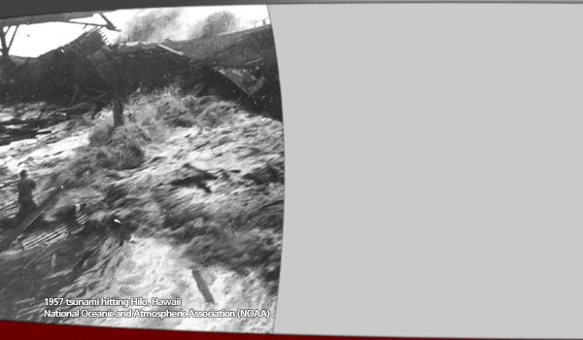

**Tsunamis**

Tsunamis are also referred to as tidal waves, although they are unrelated to tides. In Japanese, Tsunami means "harbor wave." These waves can devastate coastal communities. A tsunami is a large, fast seismic ocean wave that is triggered by underwater earthquakes exceeding magnitude 7.5 on the Richter Scale. Landslides, volcanic eruptions, or other disturbances on the ocean floor also trigger tsunamis.

During any of these events great volumes of water are displaced. The water sloshes back and forth in the ocean for several hours. In deep and open ocean waters, a tsunami consists of a series of waves that are a few feet high, and a hundred or so miles apart. Tsunami waves can travel thousands of miles from their origin. They move at speeds near 600 miles per hour, close to the speed of a commercial aircraft.

As the waves near the shore, they bunch together, grow taller, and slow down. At the shore, tsunami waves may crest higher than 100 feet and have velocities of thirty miles per hour. The waves reach the shore in series, and frequently, the first is not the worst. Many coastal cities have extensive warning systems to alert residents of approaching tsunamis.

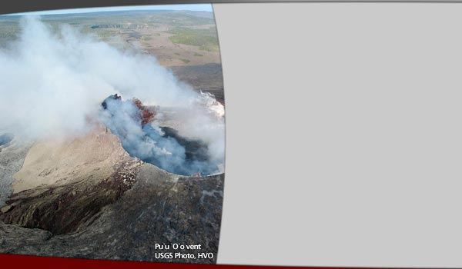

**Volcanic Gases**

Magma contains dissolved gases. During and between eruptions, these gases are released. When an effusive eruption occurs, the magma is fluid enough that the gases can escape from it easily. In the more explosive eruptions, the thick magma traps gases until they build pressure and are released explosively.

Increased gas emission is one of the first signs of activity around a volcanic vent, and often precedes eruptions. For hundreds or even thousands of years after an eruption, gases can still be emitted from fumaroles.

Steam (water vapor) is the largest component of volcanic gas. Carbon dioxide (CO2), sulfur compounds, and chlorine compounds are other volcanic gases.

Wind controls the distribution and concentration of volcanic gases. Even low concentrations can cause damage to some plants and animals downwind. Close to a vent where concentrations are high severe damage to eyes and respiratory systems of humans and animals can occur. Acid rain is created when sulfur dioxide gas reacts with water droplets in the atmosphere. It causes corrosion of metal and stone, as well as harming vegetation. Carbon dioxide is heavier than air, and can collect in basins or low-lying areas. Sometimes concentrations in these valleys and pockets can reach lethal levels and suffocate animals and people.

Volcanic smog, called "vog" for short, is a hazardous mix of carbon dioxide, sulfur dioxide and other volcanic gases that can collect downwind of a volcano and cause a persistent air pollution problem. Vog aggravates respiratory problems and causes acid rain.