Name:______________________________________________________________Period:_____________Date:________________________

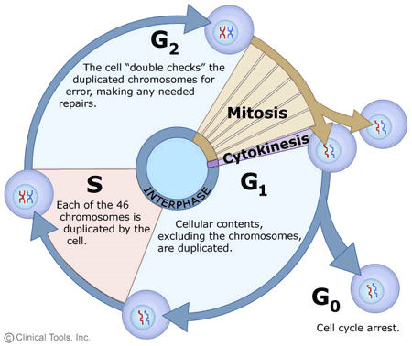
Cell Cycle Drawing
Why do cells reproduce?
- _____________________ doesn’t
work well on a cell that is too big.

- Larger cells place too much demand on the genetic info (_________)
- To _____________________________________________________

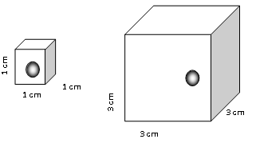

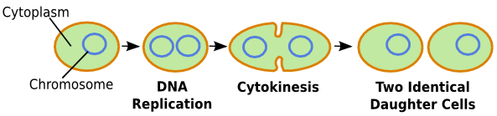
Control of the Cell Cycle
Cell cycle has key checkpoints to trigger or delay the next phase. The goal of the checkpoints is to make sure the cell is healthy, strong and completing each step correctly. DNA controls these checkpoints. A mutation in the DNA that controls the cell cycle leads to _____________________________. Ultimately the cell cycle continues even when it does not need to and cells keep dividing producing a mass of cells called a ________________________.

- What are the 3 main steps of the cell cycle?

- What is the longest phase of the cell cycle?
- What 2 main things happen during this phase?

- After DNA copies what does it look like?
- What steps involve the nucleus dividing?

- What step involves the cytoplasm dividing?

Bacteria Cell Division
Do bacteria undergo mitosis? ________________________________________
So they copy their DNA and split in two. This is __________________________

 | Mitosis | Meiosis
Goal | The goal of mitosis is to create __________________ cells with the __________ number of chromosomes to help with growth and healing. | - The goal of meiosis is to create the ________________ cells with ____________ the number of chromosomes.
Picture
Chromatin, chromosomes, chromatids, oh my!
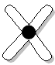
Loose uncoiled DNA uncopied copied chromosome
during Interphase chromosome each half is a chromatid
Why does DNA form a chromosome before mitosis? Remember the yarn demo….

How does each half of the X compare? Are the sister chromatids identical or different from one another?
Cell Differentiation
You start out as one cell. Before that cell divides by ____________________it makes an ____________________ copy of DNA. During __________________________, only specific parts of the DNA are ______________________; and this determines the type of cell. Once a cell differentiates, this cannot be ______________________.
How does meiosis and sexual reproduction give more diversity???

- _______________________ _____________________ of an egg and sperm.
- __________________________________________ (random organization of chromosome pairs at the equator).
- ______________________ _____________ occurs during meiosis I in which homologous chromosomes exchange pieces of chromosomes.

Cell Cycle Questions
- What is the longest phase of the cell cycle? __________________________________
- What 2 main things happen during this phase?_________________________
- What steps involve the nucleus dividing?___________________________
- What step involves the cytoplasm dividing? __________________________________

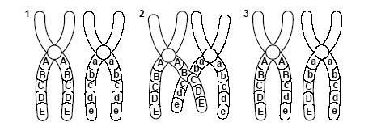
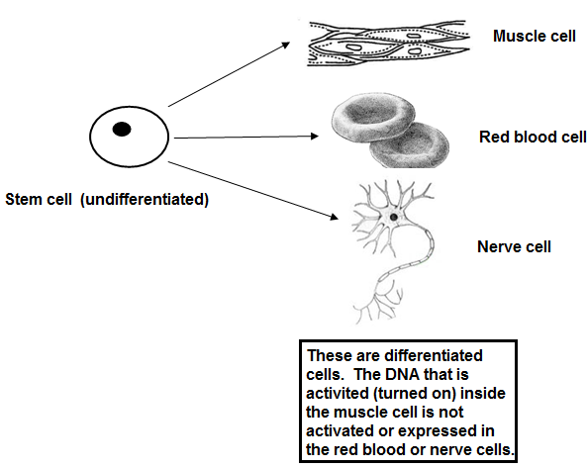
Haploid vs. Diploid Cells:
Meiosis makes the sex cells which are ________________ (have half number of chromosomes.
During _________________________ the egg and sperm join to form a _____________________ cell with both chromosomes again.
How many pairs of chromosomes does a human have? __________
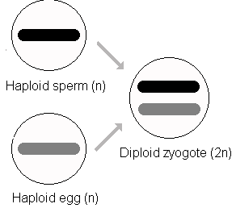
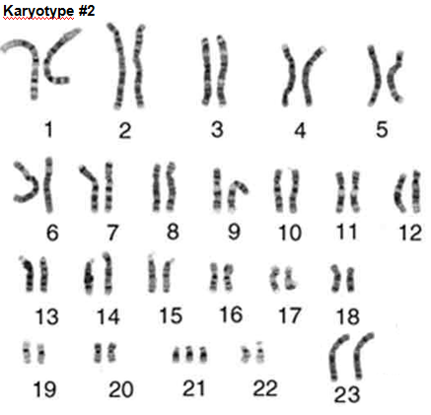
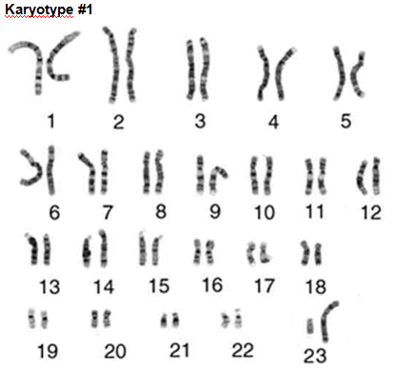
Karyotype 2:
- Is this person male or female? How do you know?
- Circle the mistake in the karyotype. This is _________________________
- This is the result of a _________________________________. This occurs when the chromosomes don’t separate during meiosis so one parent gives 2 chromosomes instead of just 1. This is also called a ________________.
Karyotype 1 – Normal
- Humans have ________ total chromosomes. _____ come from mom and the other ______ come from dad.
- Paired chromosomes are ________________________ chromosomes since they are similar to one another. Two #1’s are homologous. #1 is non-homologous to number 6.
- _______________________ - 1st 22 pairs of chromosomes (44 total)
- _______________________ - 23rd pair (2 total) determines your _______
Female (2 big) _________ Male (big and little) ________
Chromosomal Mutations
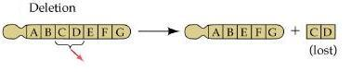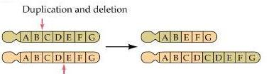
piece of a chromosome breaks off crossing over between homologous chromo. doesn’t happen evenly

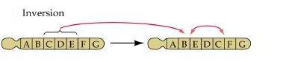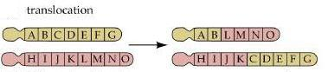
Genes on chromosome are flip flopped chromosome piece attaches itself to a nonhomologous chromosome

