Name:______________________________________________________________Period:_____________Date:________________________

The cell or plasma membrane is also known as the ___________________________________________ since it has 2 layers.
It is known as a _________________________________________________ since it is made up of many parts and is not rigid and moves easily.
The main function of the cell membrane is to maintain homeostasis by controlling _________________________________________________
The cell membrane doesn’t let everything through. It is _________________ ______________________ and only lets certain things in and out.

______________________ - polar / hydrophilic – like water
_______________________ - nonpolar / hydrophobic – hate water
______________________ - lets large/polar molecules through
______________________ - (lipid) – keeps membrane fluid
______________________ - identifies the cell
(name tag)
______________________ - receives signals (hormones)

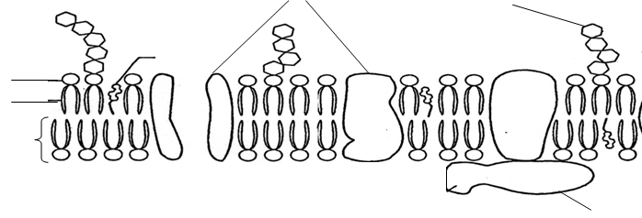

_____________________________________ | _____________________________________ | _____________________________________
Concentration of solute is ______________ outside the cell | Concentration of solute is __________ outside the cell | Concentration of solute is ______ inside and outside the cell
Water moves __________  of the cell and the cell will  ________________ | Water moves __________  of the cell and the cell will  ________________ | Water moves __________  of the cell and the cell will  ________________
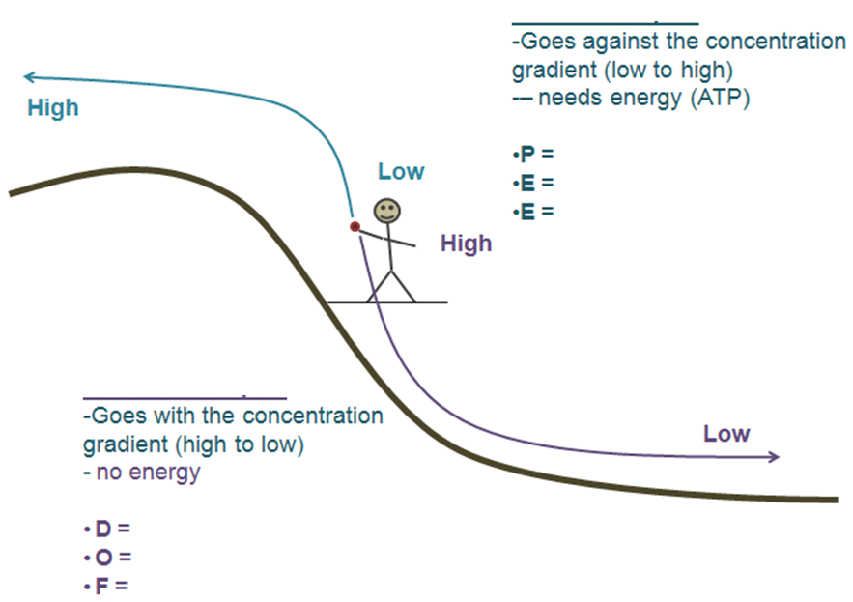
Passive vs. Active Transport
Real Life Scenarios
A saltwater fish is placed into fresh water. What will happen to the cells of this fish?

A freshwater fish is placed into a salt water tank. What will happen to the cells of this fish?

Explain the picture.

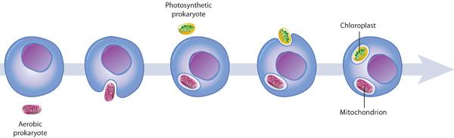
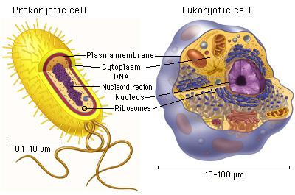
Prokaryotic vs. Eukaryotic Cells:
Prokaryotic cells - ___________________, no nucleus and no _________________________________ organelles.
Ex: ___________________________
Eukaryotic cells - __________________, have a _________________ and membrane bound organelles. Ex: _______________________________________
No matter what, all cells have 4 organelles in common:
_________________________________
_________________________________
_________________________________
_________________________________
Cell Theory
All living things are made up of one or more ______________.
All cells come from _________________________ cells.
Cells are the basic unit of structure and function of an organism.
How did Eukaryotic cells evolve?
Endosymbiosis Theory - endo means _________________, symbiotic means ____________________________ so……
Smaller __________________________ entered inside larger prokaryotes. The smaller prokaryote(s) got ________________________ and the larger prokaryote got _______________________________________________. These organelles eventually became the ____________________________ and ____________________________
Cell Specialization
Cells specialize so they can perform different functions.
________________________ - cells that haven’t differentiated, they can become any cell.

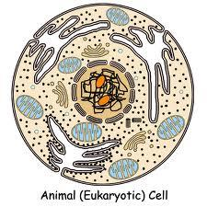
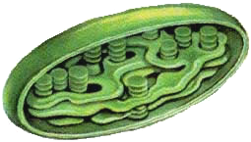
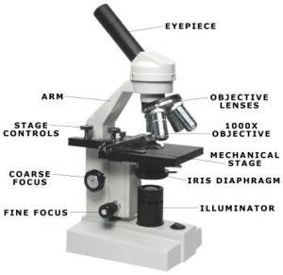

__________________________________ - small part inside of a cell with a specialized function.
Protects the DNA
Makes proteins
Site of cellular respiration - turns sugar (glucose) into useable energy (ATP)

Controls what enters and leaves the cell
Structure & support
Site of photosynthesis – uses light to make sugar (glucose)

Stores things like water and nutrients
How do we see cells and organelles???
_________________________________________________________ - uses 2 lenses and light to magnify an image up to 2000x. Can look at living cells.
Total magnification = ocular lens x objective lens
Ex: Ocular is 10x and Objective is on 40 x, what is total magnification?
__________ x ___________ = _______________
_____________________________________ - used to view larger objects. Magnifies up to 50x. Can look at living cells.
_____________________________________ - can magnify up to 200,000x but specimen must be dead.
Make sure to study your Microscope Lab to learn more about the parts and functions of the microscope. This will be on your test!

