Name:______________________________________________________________Period:_____________Date:________________________
Enzymes
- A special type of ________________________
- Function - to _____________________________ a chemical reaction by _______________________ the energy needed to start the reaction (__________________________________________)
- Enzymes are ____________________ since they only work on one type of substrate.
- Enzymes are ____________________ since they can be used over and over.
- Enzymes are affected by _______________ and ______________________. Their _________________ changes so they can no longer fit with the substrate.
Equation for a chemical reaction (_____________________________):
_________
6 CO₂ + 6 H₂O + light C₆H₁₂O₆ + 6 O₂
___________________ _________________

Organization of Life:
Atoms (Carbon or Oxygen) ____________________ (carbon dioxide, water) _____________________ (carbs)
_____________________ (chloroplast) _____________________ (plant/animal) _____________________ (muscle)
_____________________ (stomach) _____________________ (digestive) ______________________ (person)

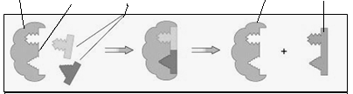

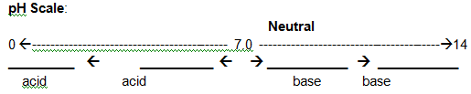
___________________ help maintain homeostasis by minimizing changes in ________. Most body systems function optimally at a pH of near _______. As the pH changes ___________________ may stop working, nerve and muscle activity weakens, and finally all chemical reactions are affected.
4 Organic Compounds HONC – 4 main elements in organic compounds  Carbohydrates  - Monomers - _____________________ Example: ______________  - Polymers - ______________________  Examples: ______________________ - in plant cell walls  _____________________ - how plants store extra carbs  ____________________ - how animals store extra carbs  - Functions ____________________________________________  - Foods include: ________________________________________  - Indicator test:  Sugar - ____________________, Positive color is ____________  Starch - ___________________, Positive color is _____________ | Lipids  - Monomers - _______________________  - Polymers - __________________________________  Examples: ______________________ - such as cholesterol that  makes hormones and parts of cells  ______________________ - make up the cell membrane  - Functions _____________________________________________  ______________________________________________________  - Foods include: ________________________________________  - Indicator test:______________________, Positive color is  a ________________________  __________________________
Proteins  - Monomers - _______________________  - Polymers - ________________________  - Functions / Examples –  ________________________________ - absorb extra sugar from blood  _____________________________ - on red blood cells, carries oxygen  _________________________________ - help with chemical reactions  - Foods include: ________________________________________  - Indicator test: ____________________, Positive color is ____________ | Nucleic Acids  - Monomers - _______________________  - Polymers - __________________________________  - Functions _____________________________________________  ______________________________________________________
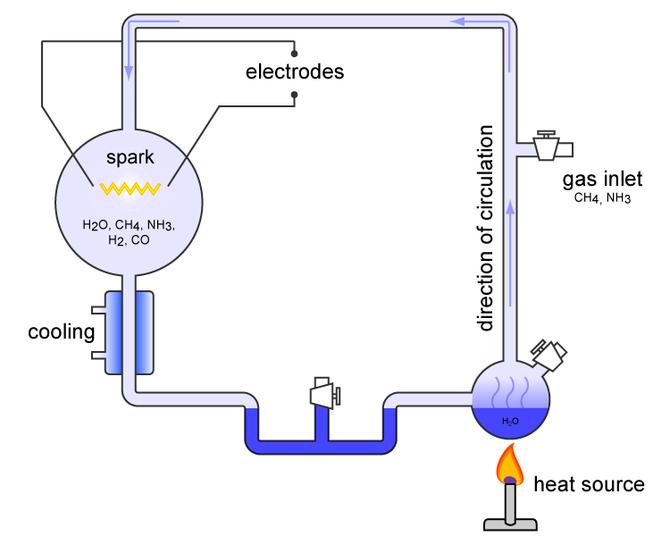
___________________ _________________________ were found in the beaker at the end of the experiment. These are the building blocks of proteins and are necessary for life.
Step 1 - __________________ __________________________________________________
Step 2 - _____________ __________________________________________________________________________________________________________________
Step 3 - _________________________ ________________________________________________________________
Why are organic compounds important???? They are needed for _____________________________________
Miller and Urey conducted an experiment to see how first organic compounds formed:

