Types of Rocks and The Rock Cycle
Date: ____________
SWBAT: Explain the rock cycle in enough detail to relate the cycling of materials.

Igneous Rocks

- Igneous rocks are _________________________________.
- Two things will determine which igneous rock is formed :
- _______________________________________

- _______________________________________

Illustrate the difference in Magma and Lava
Lava
Magma

Igneous rocks can either form deep within the Earth or near/on the surface
INtrusive igneous |  | EXTrusive Igneous
Form ______________________________________  and have been cooling for millions of years. These rocks are characterized by ___________________________________________ |  | Form on the ________________________________ When lava erupts out of a volcano it cools quick and there is little to no crystal growth
Example: |  | Example:
Texture: How big the crystals are in an igneous rock.
__________________________: Large crystals, slow cooling  _________________________: Both large and small crystals, slow cooling with different minerals |  | __________________________: Small crystals, fast cooling  _________________________: No crystals, instant cooling
Composition: _____________________________________________________________________________________
____________________________________: Most common minerals on Earth
Silica vs Iron
_________________ (light) rock made up mostly of silicates, over 65% silica | Andesitic (medium)- rock that is half dark/light, between 55-65% silica | _________________(dark) rock that is rich in Fe and Mg, Between 45-55% silica | Ultra - rocks rich in Fe and Mg, Under 45% silica

Sedimentary Rocks - Made from an accumulation of various types of sediments
  - What is sediment?
    - _________________________________________________________________________.
      - Ex. Gravel, clay, silt, pebbles, sand, mud, shells, dirt
    - Most sedimentary rock _________________________________________.
      - Ex. Limestone, halite

Sedimentary rock forms from these processes:
Weathering  Erosion  Deposition  _____________________________: sediments are pushed together and as a result, water and air are squeezed out.  _____________________________: water passes through the sediments and dissolved minerals left behind act as a cement to hold the sediments together. |  |  | ______________________: minerals clump together and fall out of solution |  | ______________________: Water evaporates and leaves dissolved minerals behind.
Three Types of Sedimentary Rocks
Clastic | Organic |  | Chemical
Definition: | Definition: |  | Definition:
Classified By: |  |  | Classified By:
Two Examples: | Two Examples: |  | Two Examples:
Features of Sedimentary Rocks
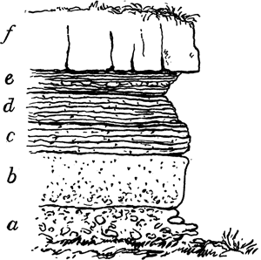  ______________________________: (aka. Layering) occurs when there is a change in the kind of sediment deposited. |  | ______________________________: formed from the action of wind or water on sand (seen in sandstone) 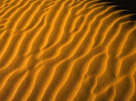 |  | ______________________________: remains or traces of plants and/or animals  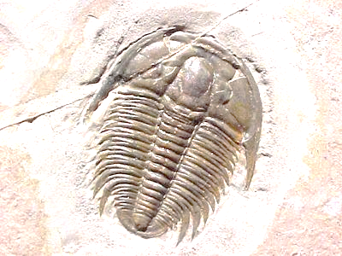

Metamorphic rocks
  - _______________________________ (igneous, sedimentary, or metamorphic) as a __________________ (from magma) ___________________________ (plate tectonics).
  - Most metamorphic rock forms below the surface of the earth.

Metamorphic rock can form in 2 ways:
Contact Metamorphism: occurs________________________________________ and changes the structure and composition of the surrounding rock. The original minerals may form larger crystals. | Regional Metamorphism: occurs when tectonic plates ______________________________________________________________________________________________ (most metamorphic is formed this way).
Metamorphic Rocks are classified according to their structure
_______________________________ Metamorphic rock  - _______________________________________________________________________________.  - Minerals with different densities separate into different bands  - EX. Slate, schist, gneiss | _______________________________ Metamorphic Rock  - ____________________________  - EX. Quartzite, marble
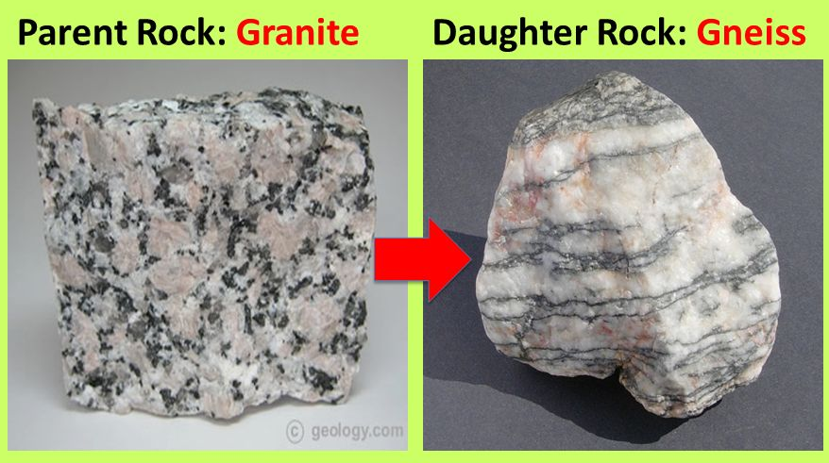
Parent rock: the rock from which a metamorphic rock is formed
  - Limestone--> Marble (u)
  - Shale--> Slate (f)
  - Granite --> gneiss (f)
  - Slate --> schist (f)
  - Quartz --> Quartzite (u)
  - Sandstone --> quartzite (u)
  - Talc --> soapstone (u)
  - Gneiss --> Schist (f)

Rock Cycle
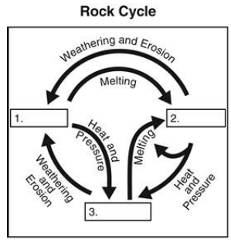
- Rock materials are constantly being recycled and each rock type can become a different type on its journey through the rock cycle.

  - _______________ that drives the rock cycle are:
    - __________________________
    - __________________________
Formation and destruction of the three major rock types
- Forces responsible
  - __________________________________ – create sediment
  - Deposition and Bedding – sediment is deposited

  - _______________________________ – transform parent rock
  - Foliation – minerals pushed into bands

  - ____________________________________– turns material into magma/lava

Weathering and Erosion
Date: _____________
SWBAT: Differentiate between and categorize types of weathering

- Weathering- __________________________________________ due to exposure to the atmosphere (H2O + gases)
- Erosion - _____________________________________________________ by natural agents (glaciers, water, winds)

Types of Weathering
Mechanical Weathering- rock is ______________________ into smaller pieces of the same material  - No change in the composition  - Ex. Rock _______________________________ ____________________________________________________________________________ | Chemical Weathering - rock’s ________________________ ________________________________________________ Change in _______________________________________  Occurs when a chemical reaction takes place between the rock and H2O, CO2, O2, or acid
Agents of Mechanical Weathering | Agents of Chemical Weathering
- _____________________________________ – rocks hitting other rocks  - _____________________________________ – water seeps into cracks in rocks, then freezesexpandsmeltsrefreezes  - ___________________________________– effective in breaking up rocks containing clay) Clay swells up when wet and shrinks when dry causing rocks to fall apart  - _________________________________– (mosses, ants, earthworms, moles)  - plant roots grow into cracks wedging rock apart; animals dig into the earth  - _____________________ – peeling of rock layers due to gravity (sheet of rock peels away) Happens to granite | - _____________________________________________  - EX. Feldspar + H2O Kaolin (clay)  - _______________________________ – Chemical reaction of _______________________________ (occurs in rocks with iron)  - Ex. Fe + O2 FeO2 (iron oxide) Hematite or rust  - __________________Chemical reaction of __________ (dissolved in water) and minerals produces carbonic acid and results in a mineral changing  - Acids – (plant decay, industrial runoff, and acid rain)  _____________________________________ rocks break apart
These two processes rarely occur alone! Mechanical and chemical weathering almost always act together.
Factors that affect Weathering Rates
- Amount of rock surface exposed: ____________________________________________________________________
- Climate: Rainfall, alternating freeze/thaw cycles
  - ***________________________________________ ___________________________________________
  - ***________________________________________ ___________________________________________
- Type of Rock: all rocks do not weather at the same rate
  - EX. Marble tombstones weather faster than granite or slate because of acid rain.

Soil
Date: _______________
SWBAT: Describe and diagram layers of a soil profile and determine how soil is formed.

Rock layers related to soil
- _______________________________: layer of weathered rock fragments that covers most of the earth’s surface
- ________________________: solid, unweathered rock that lies beneath the regolith
  - 2 types of bedrock: _________________________________________

- Made of a mixture of weathered rock particles, organic material (____________________), and air!
  - Humus: ______________________________________________________________ (from plants mostly!)
Soil is mostly sand, clay or silt
________________________: smallest particle size (less than .002 mm); weathered from rocks containing feldspar or aluminum. | ________________________: medium particle size (.002 mm - .06 mm); often found around river banks, river beds or lake beds. | _________________________: largest particle size (.06 mm – 2 mm); weathered from rocks containing quartz.
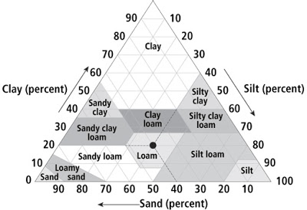
Reading a Soil Pyramid
- What is the name of soil that is
- 30 % Clay
- 50 % Silt
- 20% Sand

- What is the name of soil that is
- 20 % Clay
- 40 % Silt
- 40% Sand

Soil Profile
Cross section in which layers (a.k.a. horizons) of soil and bedrock can be seen
O Horizon |  | 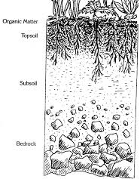
A Horizon | Consists of _____________________________________________  Usually includes leached soil deficient in humus and minerals.
B Horizon | Subsoil ________________________________________________  Made mostly of clay; rich in minerals and nutrients
C Horizon | Deepest _______________________________________________  _______________________________________________________  Unweathered bedrock

Climate determines the type of soil found in an area.
____________________________ | Thick O horizon________________________ (acidic soil)
Desert climates | Thin soil consisting mostly of regolith
Temperate climates  (Where we live!) | ______________________________________: found in areas E. of Mississippi River that receive more than 65 cm of rain a year; mostly clay, quartz and iron; acidic
 | _______________________-______________: found in areas W. of Mississippi River in areas receiving less than 65 cm of rain a year; contains Ca, less acidic, very fertile
- Soil on a mountain or hill is usually thin and of poor quality. This is because rainwater runs down and washes it away.
NC Soil
- North Carolina’s main soil type is Cecil
  - __________________________________________
  - Has a _____________________________________

Soil Conservation and Traditional/Sustainable Agriculture
Date:_______________
SWBAT: Describe methods of soil conservation.
Soil erosion is a big problem for the agriculture industry and is affected by the following factors:

Soil Conservation combats this erosion
Methods of Soil Conservation
 |  | Step like ridges are built and arranged sideways on a hill. Slows down water erosion.
 |  | Cultivated rows run sideways, rather than up and down. Slows down water erosion.
 |  | Different crops are grown on the same piece of land and rotated the next year. Catches soil eroded from other crop.
 |  | Rows of trees are planted close together to help force wind movement upward, away from the ground.
Traditional Agriculture Techniques |  |  | Sustainable Agriculture Techniques
 | The cutting and burning of plants in forests or woodlands to create fields |  |  | Growing different crops in succession in the same field  - Replenish soil nutrients
 | Most or all trees in an area are uniformly cut down |  |  | Prevent soil erosion and suppress weeds (*DUST BOWL*)
 | Preparing a field by digging, stirring, or overturning soil |  |  | Adding a layer of manure, mulch, or compost
 | Growing a single crop or plant species over a wide area and for many consecutive years |  |  | Solve pest problems while minimizing risks to people and the environment
*Techniques are evaluated on environmental quality by: Magnitude, Duration, and Frequency

Erosion and Mass Movement
Date: _______________
SWBAT: Identify and describe the four types of mass movement.

Erosion: ______________________________________________________________________________________________
- Ex. Wind, gravity, glaciers, ocean waves and currents, streams

Mass Movement: _______________________________________________________________________________________
- Talus: a pile of rocks that accumulate at the base of a slope.

Types of Mass Movements:
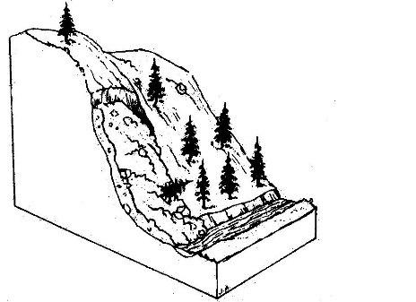 |  | - Sudden movement of ____________________ and soil down a slope of a hill, mountain or cliff.  - An avalanche is a type of landslide.  - Caused by heavy rainfall, spring thaws, volcanic eruptions and earthquakes.
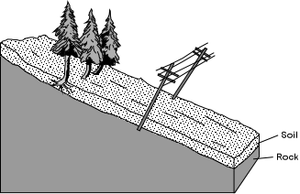 |  | - _______________________ movement of rock and soil; it will cause fixed objects such as trees, fence posts, light poles in soil to lean downhill.  - Usually goes unnoticed until objects begin to lean.  - Caused by excess water in the soil, plant roots, burrowing animals, and alternating freezing/thawing.
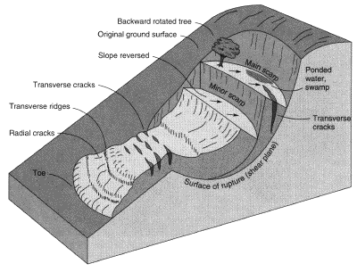 |  | - A mass of loosened rock and soil moves downhill in _____________________________________________.  - Caused by excess water in the soil which causes a loss of friction allowing rock to slip downhill.
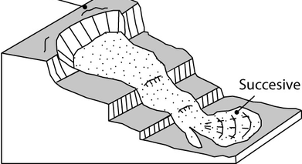 |  | - Clay and silt saturated with  ____________________________________________.  - Caused by heavy rain.  - Usually occurs in dry, mountainous regions during sudden heavy rainfall.  - Very dangerous….can wash out roads and destroy buildings.
Stabilization Methods
- In mountainous areas where mass movement is potentially possible steps are needed to prevent death and damage to property.
_______________________ retaining bolts | Drainage pipes to __________________ | Grading the slope | _______________________

Erosion by Wind
Date: _________________
SWBAT: Define saltation and describe the process of dune formation.

- Remember, erosion is the process by which weathered products are moved. Wind is one way weathered products are moved.
Where does wind erosion occur? | - Places where there is ______________________________ (plants, trees, grass)  - Places where there is ____________________ (moisture makes the soil heavier harder to move)  - Ex. Beach and desert
How does wind move sand? | - Wind causes the sand to jump and bounce. This is called ____________________________.  - Grains of sand only rise above the surface  - ~1 m even in the strongest wind.
Effects of Wind Erosion
- Deflation: ________________________________________ and leaves rock fragments that are too large to be lifted. Common in deserts. |  | - _______________________: rocks get worn down and smoothed mostly by blowing sand. | - Dunes: _________________________________________________ and causes dunes to form.  - Dunes: mounds of sand blown by the wind.  - Common in deserts, on beaches and on the shores of large lakes.

Glaciers
Date: ____________
SWBAT: Define the boundaries of world glaciers and discuss the trends in advancing vs retreating glaciers.

What are glaciers?
- Glaciers are ___________________________________ _____________________________________________  - They form near Earth’s poles and in mountains at high elevations. (_________________________________________) |  | - The snow in these areas is compacted and recrystallized into ice.  - An example of this is making a snowball.  - They cover ________________ of the Earth’s surface!!!  - In the last ice age the glaciers covered 30%  - This ice age ended 10,000 years ago
There are two types of glaciers: valley & continental
- ______________________________  - Valley glaciers are form in valleys in mountainous areas.  - They flow down the valleys like a thick liquid. (ex. Slushi)  - These glaciers will carve and widen a valley |  | - _______________________________  - A continental glacier covers a continent-sized area.  - These form in very cold, polar regions. (Ex. Antartica, Greenland)
Advancing and Retreating
- When we have glaciers that are changing size we call then advancing and retreating.
- Advancing glaciers are growing, while retreating glaciers are shrinking.
- _____________________________________________________________________________________
Glacier Erosion and Deposition
Icebergs  - Icebergs come from glaciers in a process called  ___________________. | Till and Moraine  - As the glacier moves and melts it leaves behind sediment. This sediment is called  ___________________.  - An accumulation of sediment on the sides of a glacier is called a  ___________________. | Kettle Lake and Meltwater  - Since glaciers are ice they leave behind a large amount of water as they melt.  - A kettle lake is formed when a large piece of ice breaks off and is left to melt.  - A meltwater stream is a stream formed from melted glacier water. | Glacial Deposition  - These meltwater streams can carry sediment down the glacier and then deposit them on dry land.  - This land is called an ___________________.

