Layers of the Earth
Date:
SWABT: Identify and describe the layers of the Earth and their characteristics
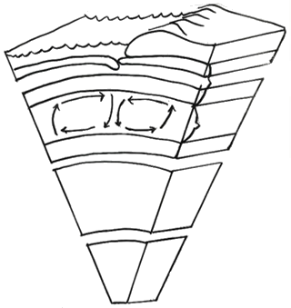
CRUST
Composition:
Thickness:
State of Matter:
______________________:
- Crust and Upper Mantle
_________________________:
- Flowing / Easily deformed

OUTER CORE
Composition:
Thickness:
State of Matter:
- Provides magnetic field
INNER CORE
Composition:
Thickness:
State of Matter:
- Due to intense pressure

_____________________:
- Mostly Granite
_________________________:
- Mostly Basalt
MANTLE
Composition:
Thickness:
State of Matter:
___________________:
- Rigid layer

Temperature and Pressure:
________________________
__________________________
___________________________

2 Main Types of Seismic Waves:
______________________________

S Waves won’t pass through:
________________________________

____________________________________:
area between crust and mantle where the
velocity of seismic waves increases abruptly.

Neither the sun’s heat nor winter cold penetrates the Earth below: ___________________________________
Below 20m, the temperature increases 1º every 40m.
Continental Drift Theory and Plate Tectonics Theory
Date:
SWBAT: List evidence for continental drift and plate tectonics theories.

Continental Drift Theory
- Started with the observation of the similarities __ of the west coast of Africa and the east coast of South America ( ).
- This led to the suggestion is that these two continents were once that had broken and moved apart.
_______________________________________: German scientist. Proposed the most famous version of the continental drift theory, but he could not explain why or how the continents drifted apart.
- His three evidences included:
Pangaea
- The last “___________________________________” (250 mya) all of the continents hooked together.
- It took over 200 million years for the continents to move to their present locations.
Plate Tectonics Theory (1965)
- Study of the theory that the earth’s crust is (solid pieces) that move
- Approximately 12 major plates
- Larger plates include
- Evidences include:
- _________________________: The same kind of animal and plant fossils were found on different continents. | - _________________________:  - Seafloor moves away from ridge (crack in crust)  - Hot ________________ comes up through crack and cools to form ____________________.  - Scientists took core samples and found that the youngest rock is near the spreading center and the oldest rock is the farthest away. | - _________________________:  - As hot magma cools it becomes solid rock and iron-bearing minerals become fixed and magnetized towards magnetic north  - Scientists discovered that some rocks have reverse magnetism.  - The pattern of magnetism on either side of the spreading center is:  _________________________
What do the two theories have in common?

Plate Boundaries
Date:
SWBAT: Identify and describe the different types of plate boundaries and where they occur.

Type of Plate Boundary |  | Sketch | Description | Features Formed | Examples
Divergent
Convergent  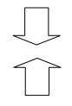 | Continental-  Oceanic
Continental-
Continental
Oceanic-
Oceanic
Transform
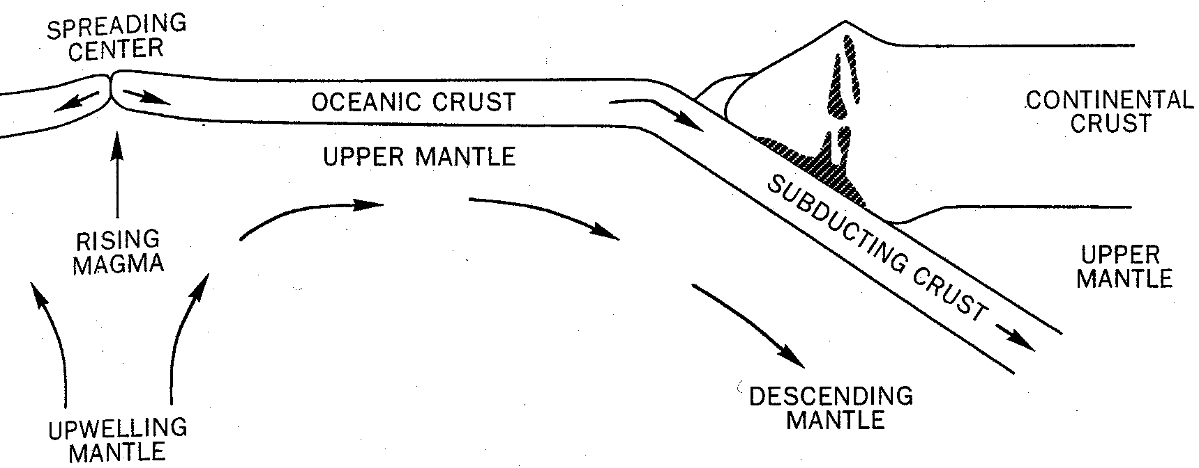
Ridge Push:

Gravity Pull (Slab-Pull):

Convection Currents: cycle of hot material rising, cool material sinking.
- This slow cyclic movement causes the plates to move like groceries on a conveyor belt.
Deformation of the Earth’s Crust
Date:
SWBAT: Match the forces to the boundary they produce and differentiate between various faults.

TYPES OF STRESS: |  | COMPRESSION | TENSION | SHEARING
ROCK MOVEMENT: |  |  | - Rocks become thinner | - Causes rocks to twist, bend, or break
PLATE BOUNDARY:
SKETCH: |  | 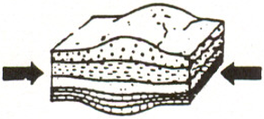 | 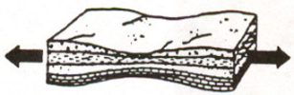 | 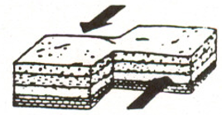
Response to Stress
FOLD | Anticline | 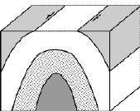
 | Syncline | 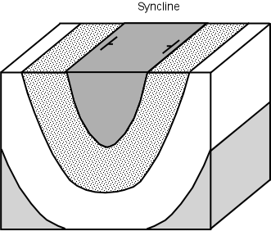
FRACTURE
TYPES OF FAULTS |  | Reverse Fault  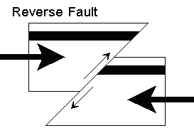 | Normal Fault  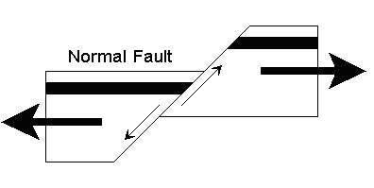 | Strike-Slip Fault  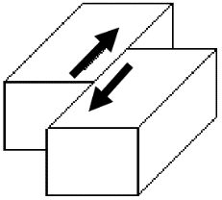

Earthquakes
Date:
SWBAT: Differentiate between earthquake measurement scales and describe the mechanics of an earthquake.

Earthquakes: _____________________________________ of the earth’s crust
- Usually occurs when rocks under stress suddenly shift along a fault.
- Earthquakes are caused
_____________________________________________________________________:
- Stress builds between two plates that are locked in place by friction.
- Plates overcome friction causing plates to move (earthquake).
- Plates snap back to their former shape.
Parts of an Earthquake
____________________________: point on the fault at which the first movement occurs. | 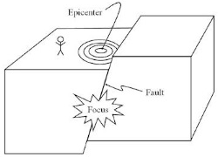 | ____________________________: point on the surface directly above the focus.
Seismic Waves
- Vibrations are called seismic waves. They radiate outward in all directions.
3 Types of Seismic Waves:
‘P’ Waves  (___________________________):  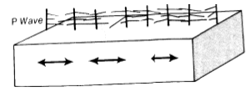  Wave Motion:  Travel Through:  Speed: | ‘S’ Waves  (___________________________):  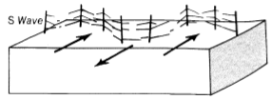  Wave Motion:  Travel Through:  Speed: | ‘L’ Waves  (___________________________):  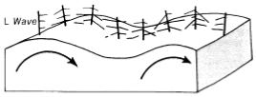  Wave Motion:  Travel Through:  Speed:
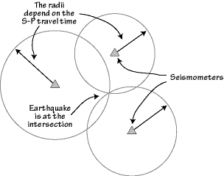
__________________________________: Instrument that detects and records earthquake waves.

- ____________________________________________________________
- Seismographs can tell how far away the epicenter is and how strong the earthquake is
- Need _________________ seismographs to determine exact location.
Scales to Measure Earthquakes
Richter Scale  - Measures _________________  - Amount of energy released | Mercalli Scale  - Measures _________________ | Rossi-Forel Scale  - Measures _________________

NC Geology
Date:
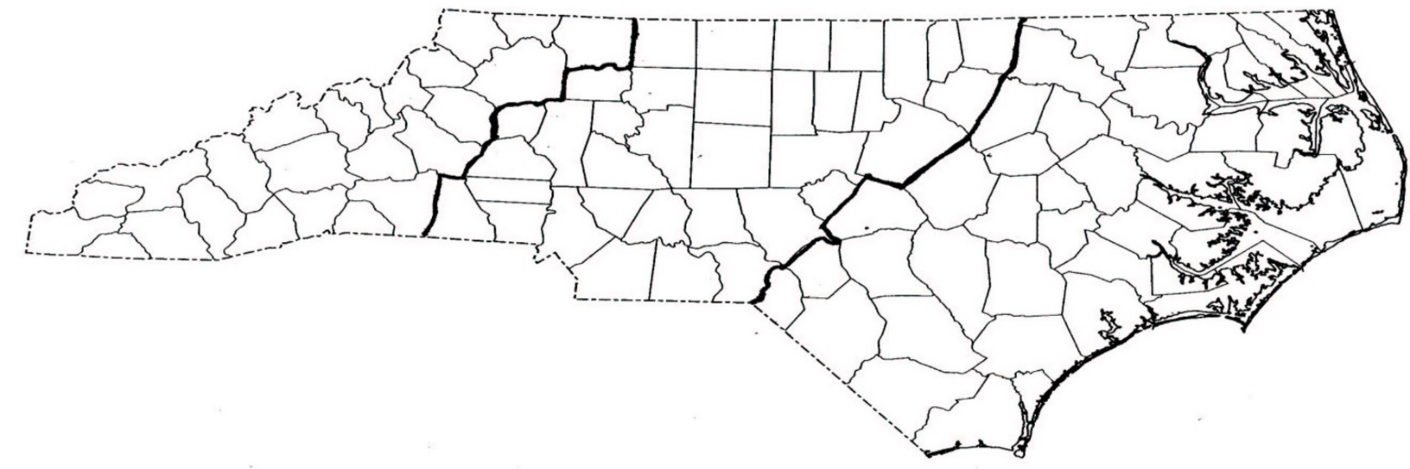
SWBAT: Connect major types of geologic processes to landforms in NC and SE United States.

______________________________________:  - Blue Ridge Mountains, part of the Appalachian Mts  - Known for their ________________  - Created from  ___________________________________  ___________________________________  - Started growing around 400 mya  (Paleozoic Era)  - Stopped growing around 270 mya | _______________________________________:  - Italian word for:  “__________________________________”  - Area less steep than the mountains but steeper than the coastal plain.  - Created by  ________________________________________________________________________ | _____________________________________:  - Flatter than the piedmont.  - Created from _______________________  ___________________________________
 |  | Inner Coastal Plain  - steeper and dryer than the outer coastal plain  - Contains _______________ | Outer Coastal Plain  - Contains  ______________________________

_____________________________________: the boundary between these two different types of bedrock.
- Piedmont and Coastal plains contain different types of bedrock.
- Piedmont is _________________________________________

- Coastal Plain is ______________________________________
NC Geologic Timeline
1.7 BYA: NC land forms
444 MYA: NC and Europe begin to collide
320 MYA: Pangaea forms with NC in heart
250 MYA: Pangaea breaks, Mountains start to weather
145 MYA: Oceans recede, Coastal plain visible
145 MYA – Present: Ocean advances and recedes multiple times

Topographic Maps
Date:
SWBAT: Interpret and construct topographic map. Predict geologic formations based off topographic maps.

Topographic Maps
- Show the _________________________________________________________________ of the Earth.
Examples of features: hills, rivers, valleys…

Topographic Maps
Contour Lines | - Connect all the points at __________________________________________________________.  - Lines never cross!  - The closer the lines, the ___________________________________________________________.  - “V” lines indicate a valley  - “V” lines always point upstream (rivers flow from high to low elevation)  - ________________________________________________________indicates hills or mountains.
Depression Contours | - Show a ________________________________________________________________________.  - Are dashed
Contour Interval | - The difference in elevation between _________________________________________________.
Contour Index | - Every __________ contour line is in _________________ and labeled with the elevation number  - Difference between 2 contour index lines divided by 5 = contour interval
Relief | - Difference between the ___________________________________________________________.  - Example: 150 ft. (highest) - 50 feet (lowest) = 100 feet (relief)

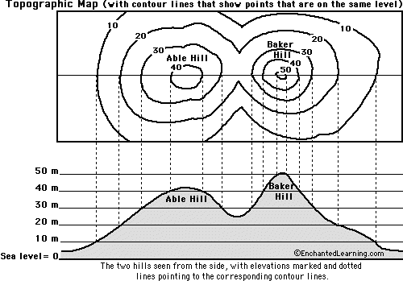
The top of this drawing is a contour map showing the hills that are illustrated at the bottom.
- On this map, the vertical distance between each contour line is 10 feet.

- Which is higher, Able Hill or Baker Hill?
- Which is steeper, Able Hill or Baker Hill?
- How many feet of elevation are there between contour lines?
- How high is Able Hill?
- How high is Baker Hill?
- Are the contour lines closer together on Able Hill or Baker Hill?

Mountain Building
Date:
SWBAT: Differentiate between mountain types. Explain the conditions for formation.

Mountains are classified by the forces that create them.
- Mountains erode slowly through action of __________________________________________________________________________________

- High elevations on mountains are _____________________________ than at sea level, which affect the ________________________________ of mountains with different elevation
- Highest Mountain: Mount Everest (Himalayas)
Mountain Type | Formation | Description | Example
Folded | 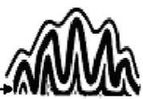 | - Tectonic movements have squeezed rock layers together.  Evidence of ____________________________
Fault Block |  | - These blocks were then lifted above the surrounding crust.  Faulting _______________________________
Dome | 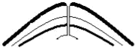 | - Resulting in:
Eroded | 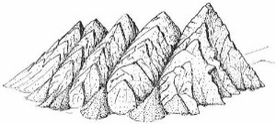 | - Leaves mountains standing between valleys.
Volcanic | 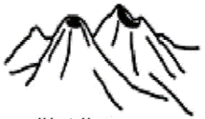 | - May develop on:
Volcanoes
Date:
SWBAT: Identify 3 types of volcanoes and tell where/how they form.

Volcanoes: An opening in the earth’s crust through which magma erupts.

Magma: Lava:
Type of Magma | Felsic | Mafic
Composition
Characteristics
Rock Formed
Viscosity- ability of a liquid to resist flowing | - High Viscosity  - Example: Corn Syrup | - Low Viscosity  - Example: Baby Oil

Type of Eruption | Boundary Type |  |  |  | Where it Occurs |  |  | Description |  | Example
Rift |  |  |  |  |  |  |  | - Non-explosive eruption  - Mafic lava
Subduction Boundary |  |  |  |  |  |  |  | - Explosive eruption  - Felsic lava  - Lava, steam, & ash ejected  - Most common
Hot Spot |  |  |  |  |  |  |  | - Eruptions can be explosive or non-explosive  - Cause unclear
Type of Volcano |  | Illustration | Type of Boundary |  |  | Type of Eruption | Type of Lava |  | Description |  | Example
Cinder Cone |  | 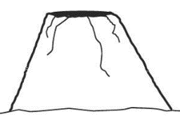  Small mountain; steep sides |  |  |  |  |  |  | - Explosive  - Cinders and rock particles are blown into the air
Shield |  | 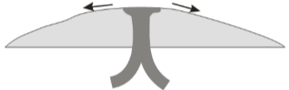  Dome-shaped mountain |  |  |  |  |  |  | - Non-explosive  - Lava quietly flows from the vent  - The mountain covers a large area; gently sloped sides
Composite Cone/  Stratovolcano |  | 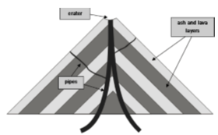  Large mountain; steep sides; cone-shaped |  |  |  |  |  |  | - Explosive and non-explosive  - A violent eruption sends up volcanic bombs, cinders and ash.  - A quiet volcanic flow follows the explosion.
Other dangers of volcanoes |  |  |  | Description
______________________________________:  Mixture of water, rock fragments and sediment that flow down the slopes of a volcano |  |  |  | - Looks like a mass of wet concrete  - Eruptions may trigger one or more lahars by quickly melting snow/ice or ejecting water from a crater lake  - Can easily grow to more than 10 times their initial size  - Typically associated with _______________________________________________
______________________________________:  Made up of tiny, dust-like fragments of jagged rock, minerals and volcanic glass. |  |  |  | - Hard, abrasive, and does not dissolve in water  - After a violent eruption, the ash in the air can be thick enough to block sunlight and lower temperatures worldwide
______________________________________:  Current of superheated volcanic ash, lava, and gas that flows from a volcano. |  |  |  | - Moves ______________________________________  - Caused when an eruption column collapses or when a dome collapses

