Intro to Oceanography
Date:
SWBAT: Describe and diagram the features of the continental margins and ocean basins.

Oceanography is the study of ___________________________________________________________________________________________________________
- draws on geology, chemistry, physics and biology

Sonar - _____________________________________________________________________________________________________________________________
- Works by transmitting sound waves toward the bottom of the ocean; sensitive receiver intercepts the echo reflected by the bottom
- Speed of sound ___________________________________________________________________________________________________________________
- The depths determined from monitoring the echoes
- Use for _________________________________________________________________________________________________________________________

The ocean floor is divided into 2 areas:
- Continental Margin:  - Shallow parts of ocean made of ____________________________  - It is not always obvious; it’s not the shoreline  - It is the dividing line between ______________________________ | - Ocean Basin  - Made of _______________________________________________  It’s the area beyond the continental rise
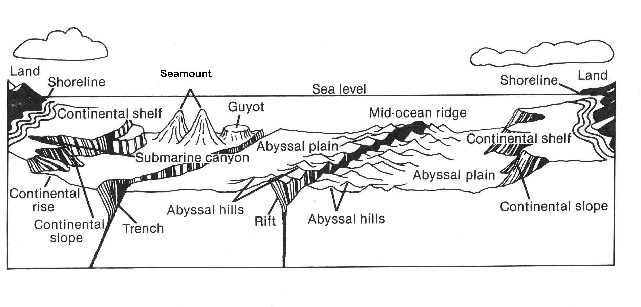

Ocean Life and Aquaculture
Date:
SWBAT: Categorize ocean dwellers by movement. Describe how we use the ocean as a food source.

Classification of Marine Organisms: Marine organisms can be classified according to _____________________________

Marine Ecosystems
- Some of the most diverse marine ecosystems are:
  - ________________________________ – freshwater and seawater mix
  - ________________________________ – near surface of tropical waters formed by skeletal deposits of coral

Term | Description
Plankton | All organisms (algae, animals and bacteria) that drift with the ocean currents.  - Phytoplankton are __________________________________________________________________  - Phytoplankton perform photosynthesis.  - Zooplankton are free floating, _________________________________________________________  - Zooplankton eat phytoplankton.
Benthos | any form of ocean life that ___________________________________________________________________
Nekton | nektos = ____________________________________  Animals capable of moving independently of the ocean currents by __________________________________  - Ex. Adult fish, squid, marine mammals and reptiles

Food from the Ocean
- Aquaculture: ________________________________________________________________________________
  - Catfish, salmon, oysters, and shrimp
Traditional  Land-based to ocean-based cultivation  - Fishing  - Substantial contributions to food supplies  - Destruction of coastal ecosystems | Sustainable  Land-based to ocean-based cultivation  - Fishing  - Plant-based feeds  - Does not negatively affect wildlife  - Supports long-term economic and social well-being of local communities
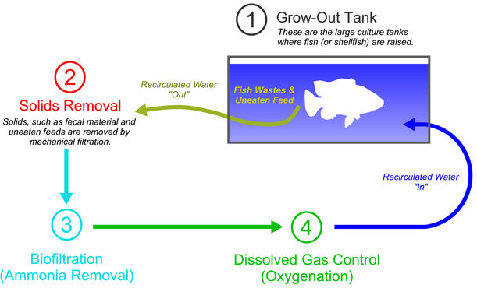
Temperature, Salinity and Acidification
Date:
SWBAT: Describe how the ocean temperature changes with depth; determine how salinity affects density.

Temperature
_______________________________________ the surface of ocean water (H₂O)  3 temperature zones of ocean water:  - Surface zone: ____________________________________; sea level to 300m;  sunlight only penetrates a few meters, but wind and waves mix heat evenly throughout the surface zone.  - Thermocline zone: marked by ______________________________________;  marks the boundary change between the surface zone and the deep zone  300-800m below sea level.  - Deep zone: _____________________________________________________ 800m-ocean floor. |  | 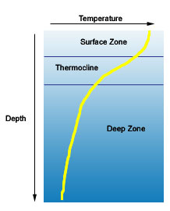
Salinity
What’s in ocean water?
- _____________________ of ocean water is H₂O
- The other ______________________ is dissolved gases and solids such as salts
  - (NaCl) Sodium Chloride is the main salt in the ocean
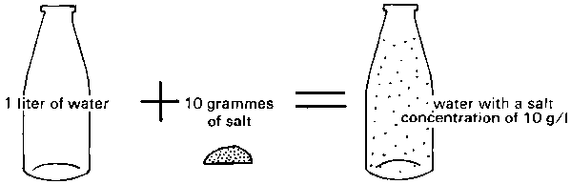
Salinity – ___________________________________________________________ (mainly salts) present in ocean water.
- Average salinity of ocean water is _____________________
  - (%o = parts salt per 1000 parts ocean water)
  - 50 million billion tons of salt in our seas
  - 1,000 g of seawater consists of ____________________________of dissolved salts
- Large amounts of _________________________________________________________________________ salinity.
- Large amounts of _________________________________________________________________________ salinity.
Each year, Earth's rivers carry more and more salt into the ocean. The water evaporates, but the salt is left behind in the ocean  - The principle source of dissolved salts in the ocean is ____________________________________________________________________________________________________________ | 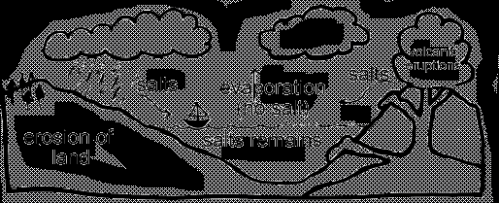
Ocean Resources
- Desalination - ________________________________________________________________________
Ocean Acidification
Excess carbon dioxide from the atmosphere makes its way to the oceans
  - The oceans are a __________________________________________________________________________
- CO₂ __________________________________ acidity of ocean water
- _______________________________________________________ especially (CaCO₃) calcium carbonate organisms
Negative impacts on fisheries
  - _____________________________________________________________________________
  - Decrease in global shellfish production and disruption of livelihoods
Currents and Climate
Date:
SWBAT: Categorize ocean currents by location, temperatures, surface and density.

Term | Description
Ocean Currents | Definition:  - Currents can be on the surface of the ocean or in deep water.
Surface Currents | Definition:  - The energy that drives surface ocean currents comes from _________________________________
Gyres | 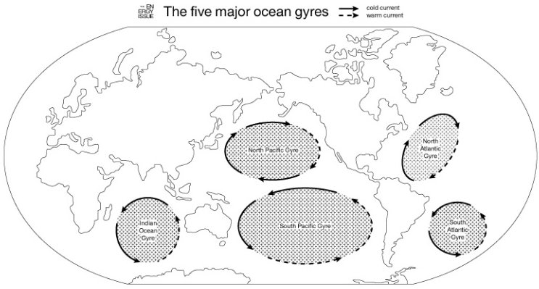  Definition:  Why do currents move in a circular pattern?  - Because of the Earth’s rotation, currents are deflected to the ___________________________ and to the ___________________________________.  This is called the Coriolis Effect
Ocean Current Impact on Climate | - Oceans maintain the balance of heat energy by ocean currents cycling between _________________________________________________________________  - When currents from low-latitude regions move into higher latitudes, they transfer heat from warmer to cooler areas on Earth  - Ocean currents are especially important to coastal regions  - __________________________________ the air temperatures along these coastal regions  An example of this is ___________________________________________________________________
Deep (density) Currents | 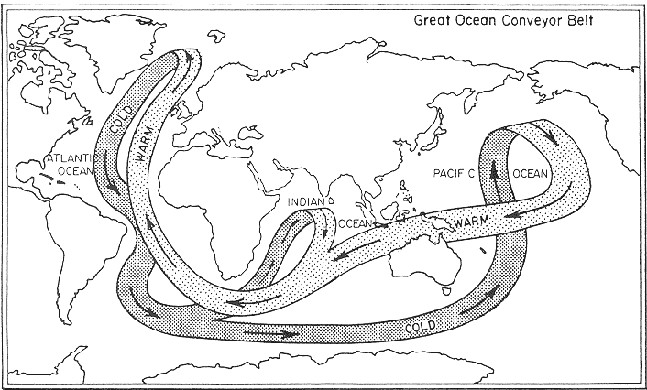  Definition:  Factors that affect the density of seawater:  - __________________________________  - __________________________________  - Decreasing temperature and increasing salinity cause water to become more dense.  Near Antarctica, surface conditions create the highest density water in the world.  - Evaporation results in increased salinity – ______________________________________________  A simplified model of ocean circulation is called conveyor belt
Upwelling | Definition:  - Winds blow the warm surface water away and it is replaced by cold waters (with lots of nutrients!)  - Deep water is very rich in nutrients and is brought to the surface.  What’s the impact of upwelling?  - Upwelling revitalizes the ocean and keeps the ___________________________________________
Waves and the Shore
Date:
SWBAT: Identify features of a wave and of wave erosion and deposition.

Term | Description
Waves | - Waves are ocean energy traveling along the boundary between the ocean and the atmosphere.  - The power of the waves is most noticeable near the shore.
Swell | Definition:
Size of a Wave | - The ______________________________________________ of the wind.  - The length of _______________________________________ the wind blows.  - __________________________________________________ – the distance the wind blows
Part of a Wave | 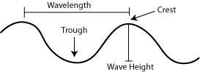  Crest:  Trough:  Wave Height: distance between the ________________________________________________________  Wave Length: Distance between ____________________________________ (either crest to crest or trough to trough.)  - The average wave length is 2-3 times the wave’s height  - Waves break in water that is as deep as one half the wavelength.  Energy in a wave- As a wave moves across the surface of the ocean, only __________________________ …not the water!
Breakers | Definition:  - If the ocean floor is ______________________, the wave breaks _____________________________  - If the ocean floor is ______________________, the wave spills forward with ____________________
Longshore Currents | 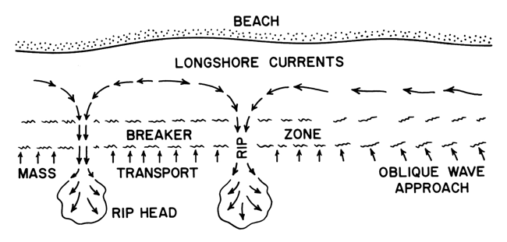  Definition:  - Occurs when waves approach the beach at an angle  - They often form long sandbars.
Refraction | 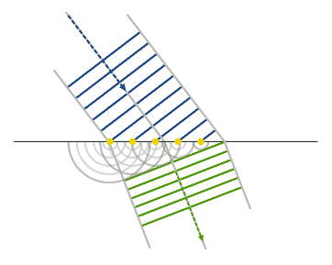  Definition:  - Refraction causes _____________________________________________  ____________________________________________________________
Undertow | Definition:  Generally a _________________________ that moves water and sand from the beach back to the shore.
Rip Current | Definition:  A ____________________________ current that _______________________________ from the beach carrying sand and water.  - How can a swimmer escape a rip current? Swim ___________________________________________

Wave Erosion and Deposition
- Waves along the shoreline are constantly ______________________________________________________________________________________________
Many shoreline features can result from this activity.
Term | Description
Wave-Cut Cliffs and Platforms | - Result from the cutting action of the surf ______________________________________________________________________________
Sea Arches and Sea Stacks | 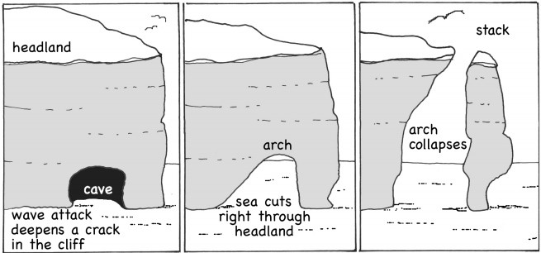  - _____________________________ that extend into the sea, and are _______________________ on all sides because of _____________________, are eroded in the center  - First forming arches and then, when the arch caves in, forming a ___________________
Barrier Islands | 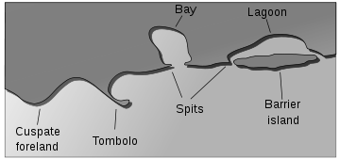  Definition:  - They are left over after a rise in sea level over time  - Or leftover sandbars after a drop in sea level
Spits | Definition:
Bars | Definition:
Tombolo | Definition:
Shoreline Stabilization | - Groins, breakwaters, seawalls, and beach nourishment are designed to ______________________________________________________  - Groins, breakwaters, and seawalls require construction while beach nourishment does not  - Only offer _________________________________________________ to shoreline problems.
Beach Nourishment | 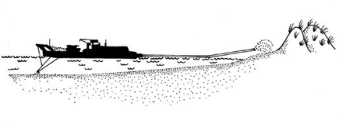  Definition:  - Most sand comes from offshore.  - Can be very expensive.  - _____________________________________________________________
Tides
Date:
SWBAT: Describe the moon’s effects on tides, calculate tidal variations, and identify the moon phases.

Term | Description
Tides | It is caused by the _______________________________________________  - The moon takes 24 hours and 50 minutes to orbit the earth.  - Thus, tides shift by ___________________________________________ |  | 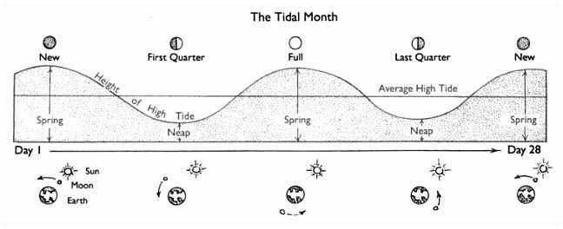
Tidal Range | Definition:
Spring Tides |  | Neap Tides
Occurrence:  Produce:  Occurs during the ___________________ and the __________________ phase  - When the Sun, Earth and Moon line up in a straight line, the combined gravity of the Sun and the moon have an effect on the earth’s oceans,  _____________________________________________________________  - Happen every _________________________________________________  - Daily tidal range is at ___________________________________________ |  | Occurrence:  Produce:  Occurs during the ___________________ and the __________________ phase  - When the Sun, Earth and moon are perpendicular to each other, their gravitational pulls ______________________________________________ _____________________________________________________________  - Daily tidal range is at ___________________________________________
Friction created between the water and the ocean floor slows the rotation of the earth. (Slowed 10.8 minutes since the dinosaurs died)
Diurnal | Definition:  Example: Gulf of Mexico |  |  | 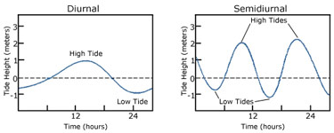
Semidiurnal | Definition:  Example: East Coast
Flood Tide | Definition:
Ebb Tide | Definition:
Slack Water | Definition:
Tidal Bore | Definition:

