Air Masses and Fronts
Date:
SWBAT: Identify the 4 types of air masses, where they originate, and their characteristics. Identify the fronts associated with the movement of these air masses
Wind | - Wind is the movement of air from places of ______________ pressure to places of ________________ pressure  - Wind moves in large masses called __________________________________________  - Air masses also move from areas of high pressure to areas of low pressure  - These air masses retain the characteristics of ______________________________________________________
Describing Air Masses | Humidity  _____________________ (dry air) vs. __________________ (moist air)  - Depending on if the air mass forms over land or water depends on if it carries a lot of moisture | Temperature  _________ (warm air) vs. _________ (cold air) vs. ________ (coldest air)  - The temperature of the air mass depends on if it formed closer to the equator or closer to the poles
 |  | Humidity
 |  | Continental | Maritime
Temperature | Tropical
 | Polar
 | Arctic
Front | Definition:  - Along a front, warmer, less dense air is always forced upwards  - 4 types of fronts
Type of Front | Map Symbol | Associated Weather | Characteristics
Warm Front |  | - Marked by long and steady rain | - A warm front occurs when warm air _________________________________ into an area covered by cooler air.  - Takes a long time for warm air to displace colder air
Cold Front |  | - Marked by _______________________ precipitation/thunderstorms for a _____________________ of time | - A cold front forms when cold, dense air quickly moves into an area occupied by warm air  - Compared to speed of warm front, cold fronts move very fast
Stationary Front |  | - Mild precipitation can occur on a stationary front | - If fronts are not moving towards each other, but rather ________________________ a stationary front occurs.
Occluded Front |  | - This will force the warm front up into the air, which will lead to heavy rain | - Cold fronts move faster than warm fronts  - When an active ________________________________________, an occluded front forms
Thunderstorms and Tornadoes
Date:
SWBAT: Describe the stages of thunderstorm formation, define lightning and thunder, and describe the necessary conditions for tornado development.

Term | Description
Thunderstorms | Definition:  - There are ~ 4,000 thunderstorms per day worldwide |  |  | Thunderstorms form when warm, humid air rises into colder air in an _________________________________
Cold Front Thunderstorms | Cause: |  | - Strong and last for:  - Can also have tornadoes and hail. |  | Occur in:
Warm Air Thunderstorms | Cause: |  | - Less violent and last: |  | Occur in:
Three Stages  of a Thunderstorm | Cumulus  Strong __________ blow ________________ air higher until the vapor condenses, forming a cumulus clouds | Mature  __________________, warm air forming ______________ clouds  - Updrafts continue and downdrafts begin as rain starts to fall  - Thunder and lightning begin |  |  |  | Dissipating  Strong ______________________ stop warm, moist air currents from rising.  - Water vapor supply suddenly decreases so the cell dies down
Lightning | - Negative charges near the __________________ and positive charges near the ____________________  - Negative charges will rush toward ground and positive charges near ground rise toward cloud |  |  |  |  |  | 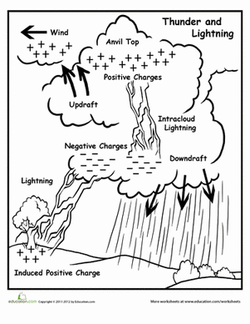
Thunder | - The extreme heat from lightning causes air to ___________________________ resulting in a loud noise  - The air expands faster than speed of sound and creates a sonic boom.
Tornado | Definition:  The center of a tornado is characterized by its  ___________________________________________ |  |  | Tornado Intensity: EF0- EF5  Measured on:  - Measures how much damage is done by the tornado and wind speed
Tornado Alley | Location: |  |  | Air Mass Interaction:
Tornado Warning System | Watch |  |  | Warning
 | - Conditions are conducive to the development of tornadoes in and close to the watch area.  - _______________________________ area  - Can last 3-5 hours |  |  | - A tornado has been sighted by spotters or indicated on radar and is occurring or imminent in the warning area.  - __________________________________ area  - Can last 30 min – 1 hour
Hurricanes
Date:
SWBAT: Identify the ingredients for hurricane formation and describe the rating scale.

Term | Description
Hurricanes | Definition:  - Hurricanes go by different names in other parts of the world, these severe tropical storms can be called:  - In the Pacific they are called ______________________________________  - In the Indian Ocean they are called cyclones
Parts of a Hurricane | __________________________________ – center of the hurricane  - Calmest and warmest part of the storm. |  |  | __________________________ – Thick clouds surrounding the eye with the most intense winds of the hurricane
Stages of a Hurricane | ____________________________:  Is the first stage of consisting of a mass of thunderstorms that have only a slight wind circulation. | ____________________________:  Whirling area of low pressure and storm activity with sustained winds up to 38 mph. | ____________________________: Sustained winds over 39 mph. This is the stage when the storm is given a name. |  | ____________________________: Winds over 74 mph
Storm Surge | - Greatest __________________________________ from hurricanes comes from the storm surge.  - Storm Surge - a combination of high tide and water that is pushed onshore by the strong winds of a hurricane; can produce surges 1-5.4+ meters.  - Most deaths from hurricanes are by _____________________________________ due to the storm surge.
Hurricane Classifying | Hurricanes are classified according to intensity using the ________________________________________________________________________
 | Category | Sustained Winds (mph) | Surge (ft) |  | Damage
 | 1 | 74-95 | 4-5 |  | Minimal
 | 2 | 96-110 | 6-8 |  | Moderate
 | 3 | 111-130 | 9-12 |  | Extensive
 | 4 | 131-155 | 13-18 |  | Extreme
 | 5 | 156+ | 19+ |  | Catastrophic
Hurricane Warning System | ____________________________________________________:  issued several days before landfall |  | ________________________________________________________:  issued 24 hours before landfall
Hurricane Season | South East:  - The interaction between ocean ___________________________________ and __________________________ masses contributes to the formation of hurricanes during the late summer
Weather Maps and Forecasting
Date:
SWBAT: Use station models to interpret weather maps and identify tools meteorologists use to forecast the weather.

Term | Description
Station Models | - Meteorologists collect data from all over the country to help them predict the weather.  - The data is represented in a station model, which is comprised of symbols that stand for different things. The data represented includes: |  |  |  |  | 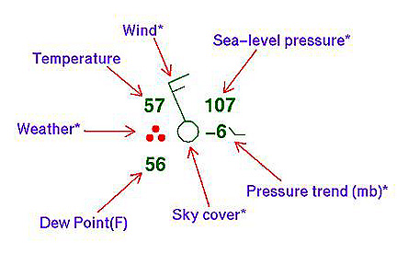
Weather Maps | Once you have collected data from all of your station models, you can put it together and form a weather map.
 | Isobars:  - _________________________________ spaced = increased wind speed.  - _________________________________ spaced = calm winds.  - Closed circles = areas of high or low pressure. |  |  |  |  | 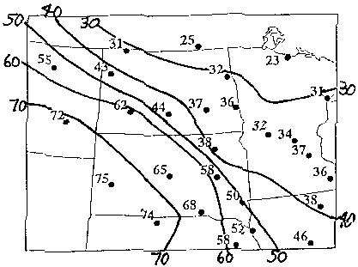  Isotherms:
 | Cold Front: | Warm Front: |  |  | Occluded Front: |  |  | Stationary Front:
Weather Instruments | What is it?  What does it measure? | What is it?  What does it measure? |  |  | What is it?  What does it measure? |  |  | What is it?  What does it measure?
 | What is it?  What does it measure? |  |  | What is it?  What does it measure? |  |  | What is it?  What does it measure?
- These instruments typically measure conditions in the lower atmosphere.
- A radiosonde:

- Satellites can be used to determine weather conditions in the upper atmosphere.
El Niño and La Niña
Date:
SWBAT: Identify the causes of El Niño and La Niña and the weather patterns they create.

Term | Description
Normal Conditions | Air Pressure: |  | Trade Winds: |  | Pacific warm pool on western side |  | Thermocline: |  | Upwelling:
El Niño-Southern Oscillation (ENSO) | Air Pressure: |  | Trade Winds: |  | Warm pool migrates eastward |  | Thermocline: |  | Downwelling  - Lower _____________  ______________________  - Corals particularly sensitive to warmer seawater
Global consequences of El Niño | El Niño has global consequences and is both an atmospheric and oceanic phenomena
 | _________________ in SE Asia and Australia | __________________and increased rainfall in S. America |  | Strong ____________ on US West Coast |  | Northward displacement of Jet Stream |  | __________________trade winds |  | Causes more winter rain in Texas, mild winter in Midwest
ENSO Events | Strong conditions influence global weather  - Flooding, drought, erosion, fires, tropical storms, harmful effects on marine life
La Niña | Opposite of: |  | Surface temperatures in the eastern Pacific are  _________________________  than average |  | Winter-lots of colder than normal air blows over the Pacific Northwest, but warms the rest of the US |  | Trade winds are especially ______________________ |  | Can also increase ______________________
ENSO Event | - El Niño warm phase about every 3 to 8 years  - ___________________________________________________________________  - Phases usually last 12 to 18 months  - Currently in an El Nino!
