Lab Safety Rules
Date: __________________
SWBAT: Identify and practice lab safety procedures
- Report all accidents to the teacher IMMEDIATELY! Never handle broken glass!
- Follow all written and verbal instructions carefully
- Bring only your lab worksheet and a pencil to the lab area
- Do not enter any lab storage area unless instructed to do so by the teacher
- No food or beverages in the lab area
- Never touch or taste chemicals without the teacher’s permission
- Waft fumes to smell odors. Do not sniff or breathe deeply, directly from the chemical
- Wear goggles when instructed to do so; especially when a flame is present
- Do no discard ANY solids in the sink
- No horseplay (running, shoving, playing around) in the lab area
- Use common sense! Ask if you have a question
- Perform only the experiment given to you by your teacher
- Ask the teacher if you do not know how to use a piece of equipment
- Read the instructions before beginning the experiment. Do them in the order listed
- Always clean up your lab area when you are finished
- Wash hands after you finish a lab. Soap and paper towels are available at each station
- Know the location of the safety equipment. Know the fire drill procedure
- Keep hair tied back and clothing out of the way (roll up sleeves, remove ties, and bulky coats)

Intro to Earth Science
Date: __________________
SWBAT: Describe and define the 4 branches of Earth Science
What is Earth and Environmental Science?
- The study of the Earth and the universe around it.
- The Earth and its environment are divided into spheres that overlap and interact.
There are five major branches in Earth Science: Geology, Hydrology, Meteorology, Ecology & Astronomy
Geology – Lithosphere:
The solid Earth
Hydrology – Hydrosphere:
All of the Earth’s water
Meteorology – Atmosphere: The air that surrounds Earth
Ecology – Biosphere:
All life on Earth
Astronomy – Celestial Sphere: The universe beyond Earth
Properties of Earth
The Earth is magnetic |  | The Earth has gravity

Scientific Method
Date: _____________________
SWBAT: Identify and describe the steps of the Scientific Method. Be able to use the scientific method to design an experiment

In order to understand the world we need to have a goal in mind, this is where the Scientific Method comes in.

What is the Scientific Method?
Steps |  | Description
- Ask a Question/Observe a Problem
- Background Research
- Constructed a Hypothesis  “If, then statement” |  | Hypothesis is a: __________________________________________________  _______________________________________________________________
- Test Hypothesis
- Analyze Data and Draw Conclusion
- Repeat
Parts of an Experiment
Variables:  things that change | Independent Variable
 | Dependent Variable
Constants : things that don’t change
Control
Laws vs Theories
Law  - You drop a pencil.  - The LAW of gravity states that it will fall, it does not matter why it falls |  |  | Theory  - You find a fossil of a half reptile/half bird.  - The THEORY of evolution tries to explain why.

Metric System and Measurement
Date: ___________________
SWBAT: List in order the prefixes of the metric system. Change from one unit to another

The Metric System
Measuring | Units | Calculated using
Length -
Mass -
Temperature -
Volume –

Density –

- Would the objects with the following densities float or sink in pure water?
  - .85 g/mL
  - 1.4 g/mL

Converting Metric Units
Kilo (K)  1000 | Hecto (H)  100 | Deca (da)  10 | Unit  (gram, liter, meter)  1 | deci (d)  0.1 | centi (c)  0.01 | milli (m)  0.001
Step 1: Write the sentence to help remember the order of the prefixes

Step 2: Identify where you are
Step 3: Identify where you want to go
Step 4: How do you get there? (Right/Left, How many space?)

Problem: 2 m = ________ km

Practice: 2000 mg = ____________________ g 104 kL = ___________________ dL 480 cm = ________________m

Converting Standard Units
In the box method, we always make sure our units cancel, so…….. ALWAYS WRITE YOUR UNITS!!!!!!!!!!!!!!!
Step 1: Draw box
Step 2: Put starting measurements in top left
Step 3: Set up so units cancel

Problem: 10 ft = _______ in

Latitude and Longitude
Date: _________________
SWBAT: Explain how to use and plot latitude and longitude to find locations.

Coordinate System
Latitude: North and South of the Equator  - AKA: | Longitude: East and West of the Prime Meridian  - AKA:
Reference - Equator Latitude:  North Pole Latitude:  South Pole Latitude:  Tropic of Cancer Latitude:  Tropic of Capricorn Latitude:  Arctic Circle Latitude:  Antarctic Circle Latitude: | Reference - Prime Meridian Longitude:  International Dateline Longitude:
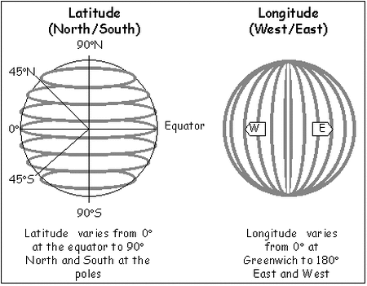
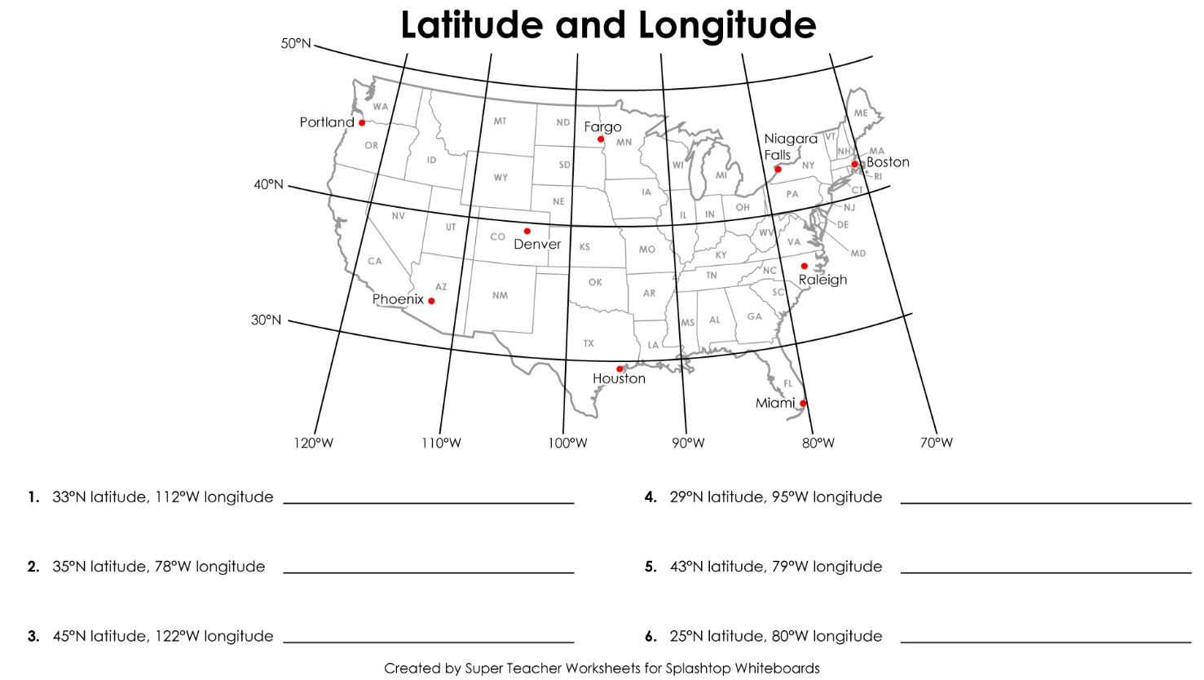
Coordinates are always
written like an (x,y) plot.
(Latitude, Longitude)

Topographic Maps
Date:
SWBAT: Interpret and construct topographic map. Predict geologic formations based off topographic maps.

Topographic Maps
- Show the _________________________________________________________________ of the Earth.
Examples of features: hills, rivers, valleys…

Topographic Maps
Contour Lines | - Connect all the points at __________________________________________________________.  - Lines never cross!  - The closer the lines, the ___________________________________________________________.  - “V” lines indicate a valley  - “V” lines always point upstream (rivers flow from high to low elevation)  - ________________________________________________________indicates hills or mountains.
Depression Contours | - Show a ________________________________________________________________________.  - Are dashed
Contour Interval | - The difference in elevation between _________________________________________________.
Contour Index | - Every __________ contour line is in _________________ and labeled with the elevation number  - Difference between 2 contour index lines divided by 5 = contour interval
Relief | - Difference between the ___________________________________________________________.  - Example: 150 ft. (highest) - 50 feet (lowest) = 100 feet (relief)

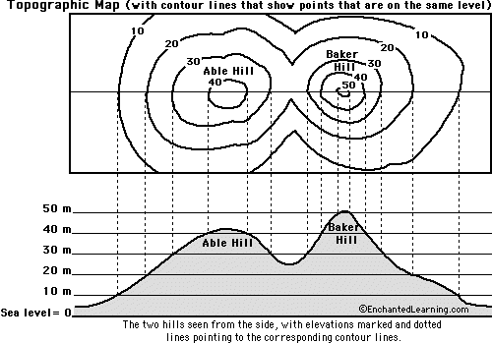
The top of this drawing is a contour map showing the hills that are illustrated at the bottom.
- On this map, the vertical distance between each contour line is 10 feet.

- Which is higher, Able Hill or Baker Hill?
- Which is steeper, Able Hill or Baker Hill?
- How many feet of elevation are there between contour lines?
- How high is Able Hill?
- How high is Baker Hill?
- Are the contour lines closer together on Able Hill or Baker Hill?

